# Instructions

The Web development team is having trouble working with some of the services that you have previously installed on their server.

Check to make sure the following services are started and enabled on the system:

Samba (There are two services, **smb** and **nmb**)

Apache (The service name is **httpd**)

SSH (The service name is **sshd**)

They would also like to monitor the CPU usage on the system. They request that you create a log file that displays the all running processes sorted by CPU usage. They would like this log to record this data every weekday at noon. Please be sure to include timestamps in the log file.

# Screenshots

Paste the required screen shots under each description.

1. Paste a screen shot showing the status of each of requested services (4 total)

1. Paste a screen shot of the script you created to run the log file

1. Paste a screen shot of the crontab file showing the schedule for the script to run

# Documentation

Record and explain all the steps you took to complete the task. Include any commands used, screen shots showing GUI interfaces, or any other information that would help you recreate the task.

**Note: You will be allowed to use this documentation to help you complete future assignments.**

Step 1.

1. Services to check:

Samba (smb and nmb)

Apache (httpd)

SSH (sshd)

1. Commands used:

Check Samba (smb) status:

sudo systemctl status smb

Check Samba (nmb) status:

sudo systemctl status nmb

Check Apache (httpd) status:

sudo systemctl status httpd

Check SSH (sshd) status:

sudo systemctl status sshd

Step 2.

1. Create the script:

Open a terminal and create a new script:

sudo nano /usr/local/bin/cpu_usage_log.sh

1. Script content:

#!/bin/bash

# Log file path

LOG_FILE="/var/log/cpu_usage.log"

# Append timestamp to the log file

echo "Logging CPU usage on $(date)" >> $LOG_FILE

# Log running processes sorted by CPU usage

ps aux --sort=-%cpu >> $LOG_FILE

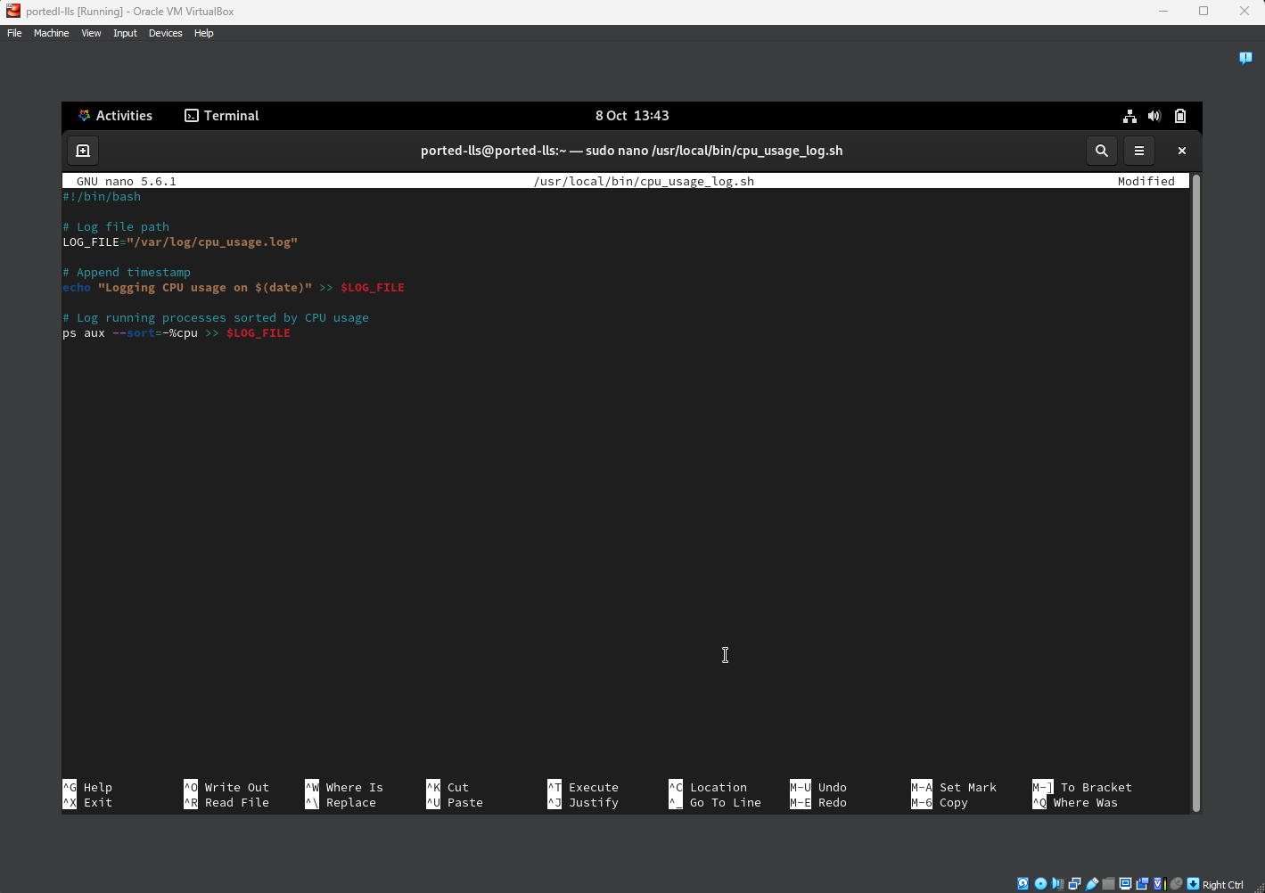

1. Save and exit the script editor by pressing Ctrl + X, then Y, and Enter.
2. Make the script executable:

give the script execution permissions using:  
 sudo chmod +x /usr/local/bin/cpu_usage_log.sh

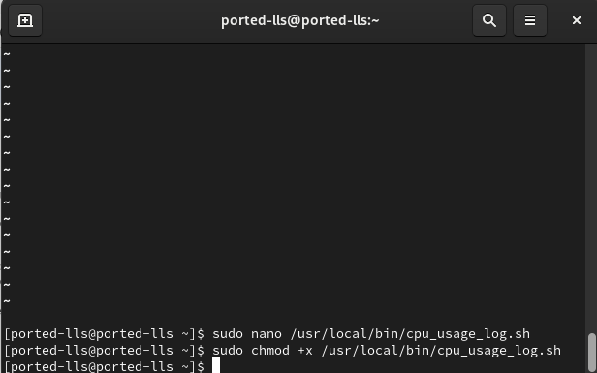

Step 3: Scheduling the Script to Run Using cron

1. Edit crontab: sudo crontab -e
2. Added the following line to schedule the script to run every weekday (Monday to Friday) at noon: 0 12 * * 1-5 /usr/local/bin/cpu_usage_log.sh
3. Save and exit the crontab editor.
4. Explanation of the crontab entry:

0 12 — The script will run at 12:00 PM (noon).

* * 1-5 — The script will run every day from Monday (1) to Friday (5).

/usr/local/bin/cpu_usage_log.sh — This is the path to the script I created.

